
TP : Introduction to design with ADS
Simulation of transmissions lines
By ISSA SIDIBE & LOUIZ KHEROUS

03/12/2023
Introduction :
This laboratory session serves as an introductory lesson in electronic design, specifically regarding transmission lines. The aim is to comprehend microwave simulation techniques and interpret the outcomes. Our subsequent focus will be on analyzing frequency domain responses.

Part 1 Simulation of an RF circuit using ADS built-in models. for 7mm line (B) at 2GHz
With Zc = 50 ohm

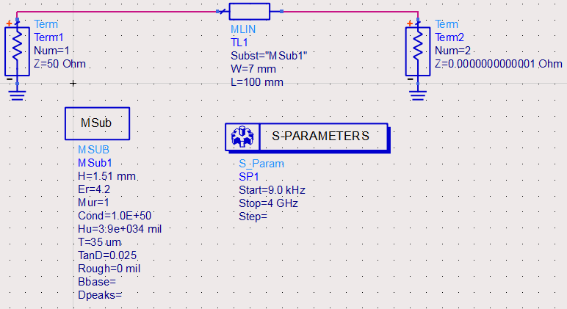

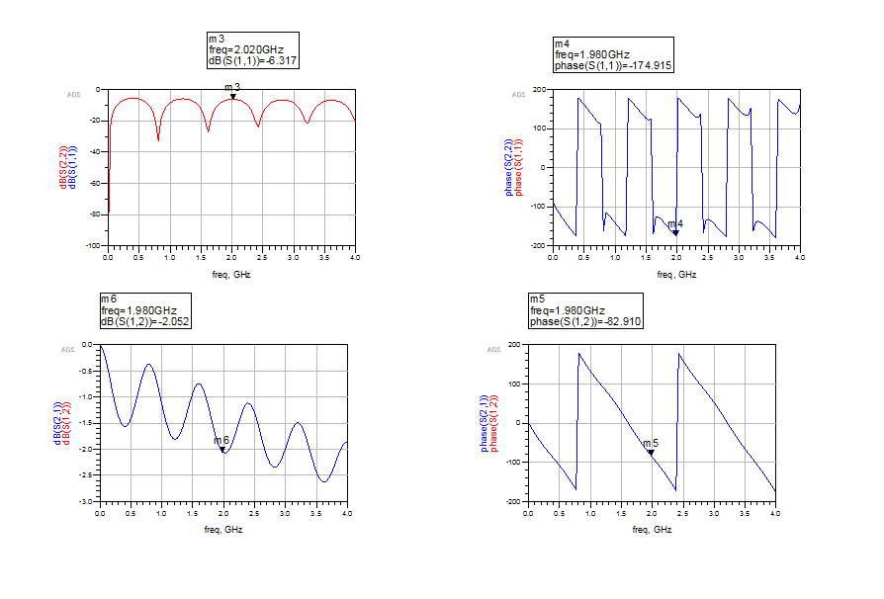
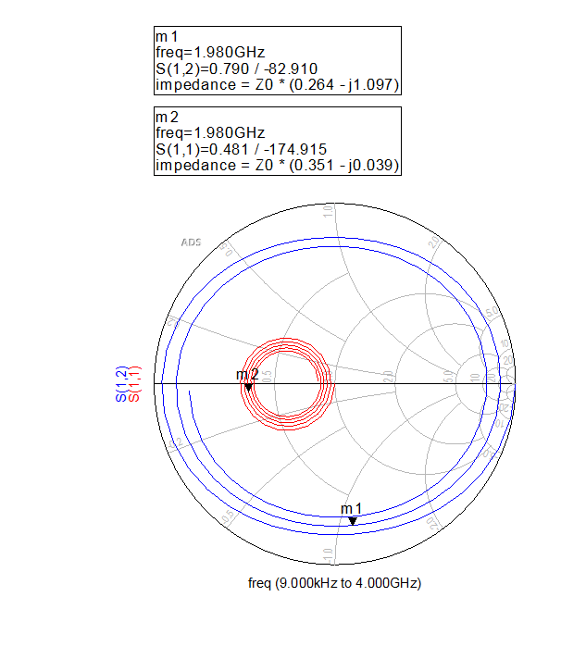
a- Comparaison between software simulation and real simulation values

 | Real simulation in dB | ADS in dB
S11 | -5.5 | -6.3
S22 | -5.5 | -6.3
S21 | -2.2 | -2.052
S12 | -2.2 | -2.052

We notice that these results are quite close but just some difference due to real life phenomena (parasitic signal etc.)
S11 = S22 = -5.5 dBthat means we reached the impedance matching almost no reflexion
S12=S21= -2.2 dB that means we have less losses in our transmission line

b- Paramaters evaluation in open cicuit case
With Zc = 1M ohm
For an open circuit case we observe that the output reflexion coefficent S22 is at 0dB and its different from S11
when there's an open circuit at the output port, the reflection coefficient S22 would indeed be 0dB (zero) as all the signal is reflected back due to the open termination.
Regarding the transmission coefficient we observe that S12=S21= -114 dB we observe a strong attenuation of the transmitted signal at 2 GHz
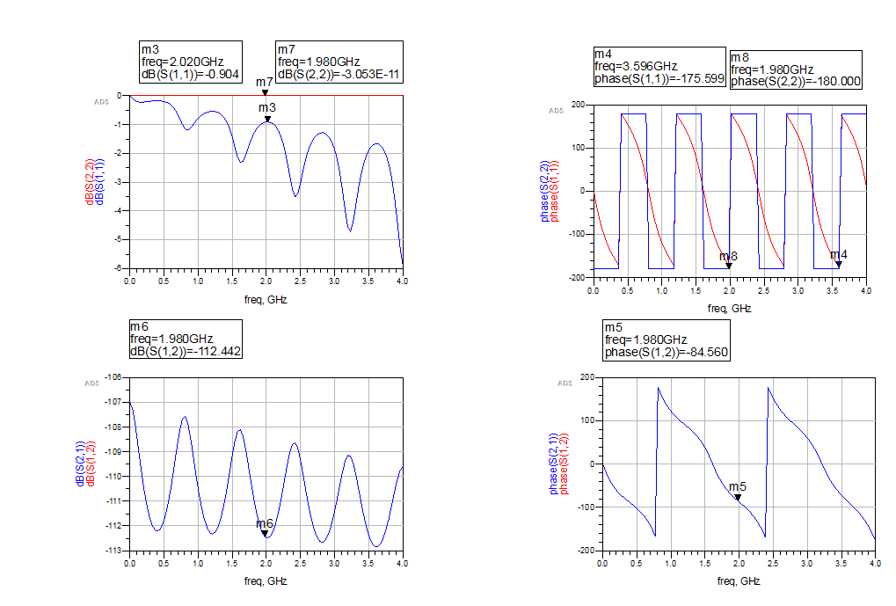
smith chart in open cicuit case
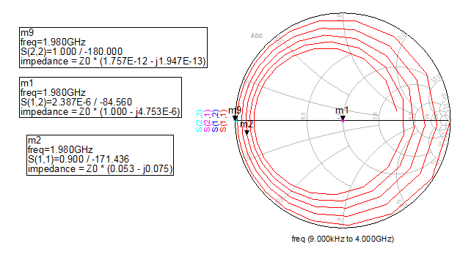
Regarding the smith chart as the m9 (S22) is at extrem right we cna deduce that we are in total reflexion case on the output

b-2 Paramaters evaluation in short cicuit case ZL=0 ohm
For a short circuit case it’s the same case than the previous one we have a total reflexion regarding the output S22 which is in fact correct by using theorical formula
The transmission coefficient has again a strong attenuation -137 dB

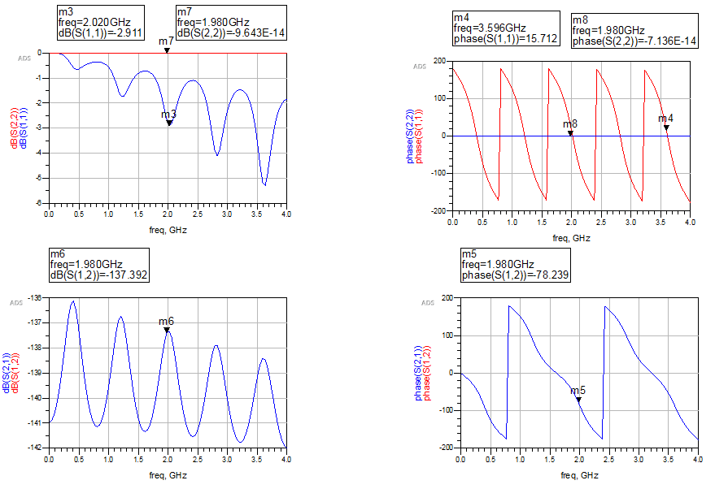

smith chart in short cicuit case
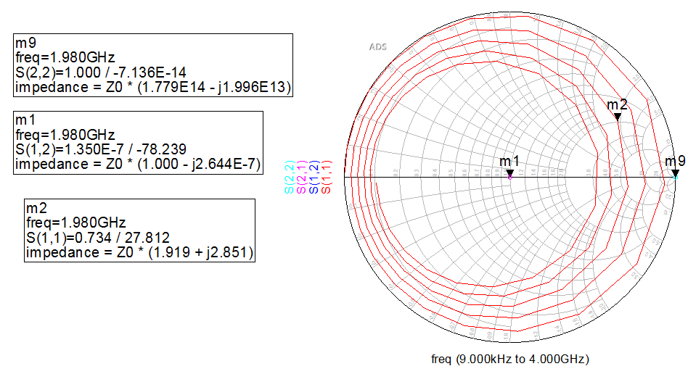

Regarding the smith is just confirmed the previous interpretation ; We observe that m1 (S12) is well centered on 1 that means the impedance there is 50 Ohm ; m9 (S22) is at 0 extrem left that means we have a total reflexion

c. Calculation of the impedance of the line
After well dedined the line properties we have calculated the Characteristic impedance of the line
We find Zc close to 50 ohm
(the picture below was before calculation )
The simulations result are right

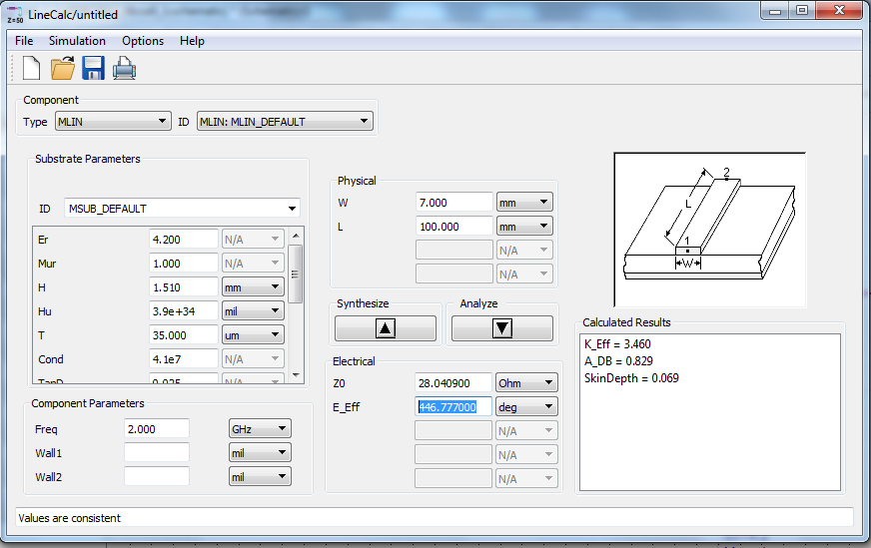

- Result comparaison between the reflexion by defining Zc (S11 and S22) and the reflexion by using Zc calculate by the software (S33 and S44)

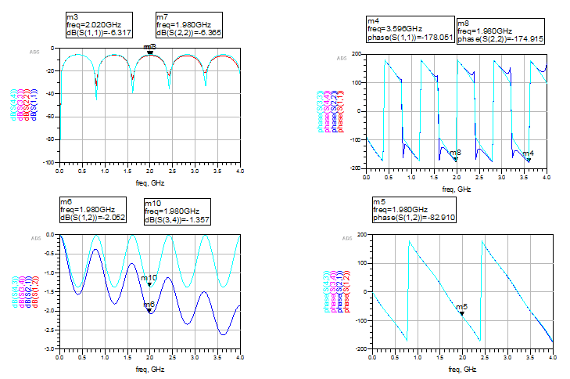

smith chart
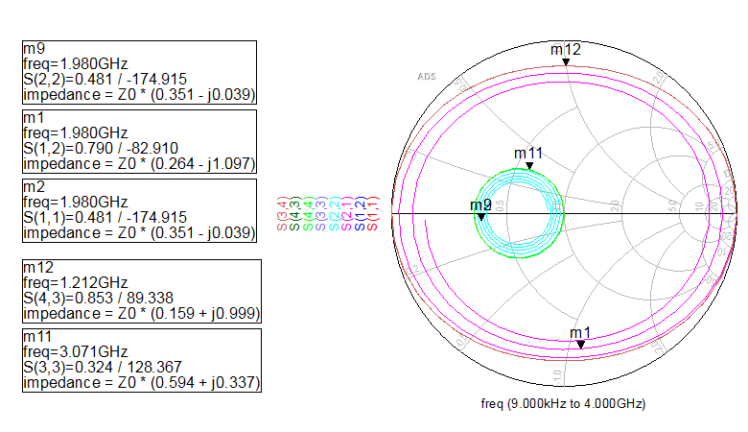
Regarding S11= S22 and S33=S44 we retrieve the same value for the both case with whever the defined or the calculated Zc that means the value is correct we could just define the properties of the line and the software would calculate the adapted Zc by itself
Regarding the coefficients are equal in term of phases but magnitudes are different when we are getting close to higher frequencies.

The Smith Chart shows that S43 =S21 has an inductive behavior while S12 = S34 has a capacitor one And S22 =S44 is real it is on the real axes

Part 2 – Momentum simulation
1 - Definition of the line properties on the Layout
Line microstrip from length equal à 100 mm Engraved on one substrate dielectric FR4 (εr=4.2; tgδ=0.025) 1.51mm thick. Metallization thickness (copper) east equal to 35 μm. The line has a width equal to 7 mm.
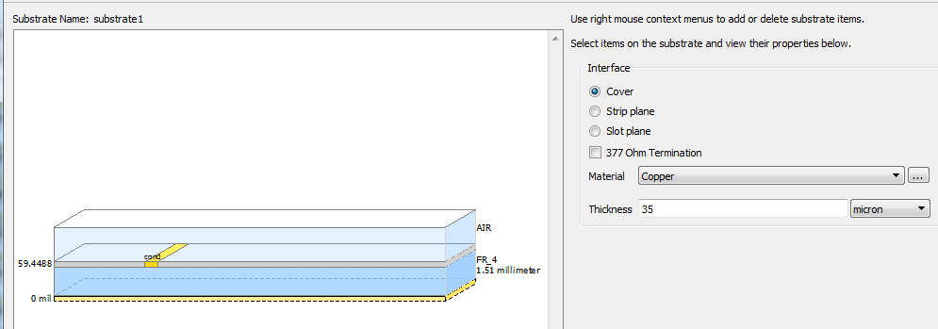

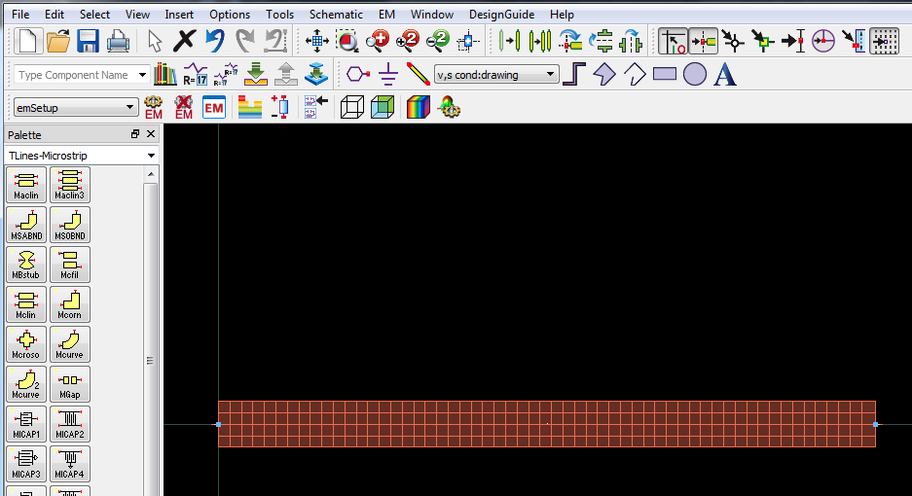

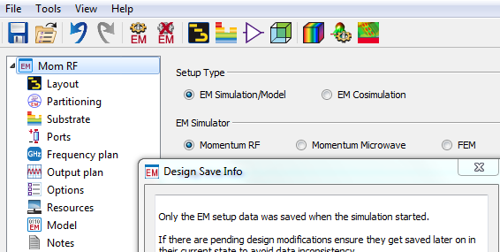

2-Simulation results
Comparaison between the Momentum S-parameters and the previous result (cell 1 at defined Zc=50 Ohm)
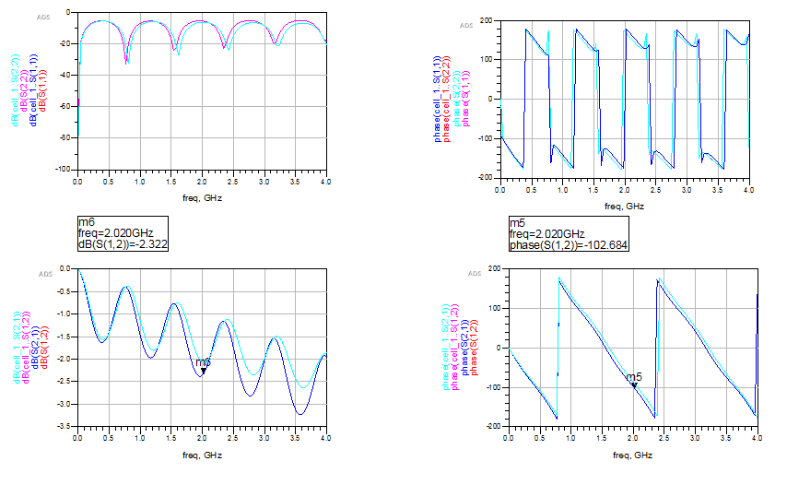
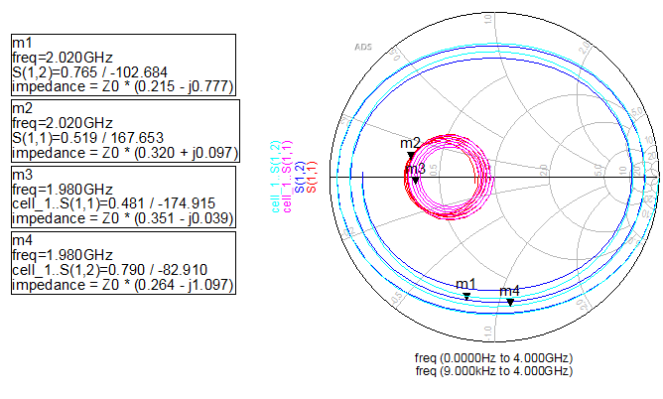
In fact the both simulations results are quite similar this show we have the same reflexion coefficient with a very low reflexion ; and a reflexion coefficient with less losses -2.2 dB
It is just another way of simulation
the smith chart show us S parameter modulus and the normalized impedance
m4 and m1 show a capacitive impedance behavior (S12 in the both case)
Conclusion :
This laboratory work demonstrates various methods of microwave simulation. We explored the utilization of the Smith chart, S-parameters, and Momentum simulation. The importance of adaptation in information transmission was highlighted. ADS provides diverse simulation options to analyze our line before execution.

